**LAPORAN PRAKTIKUM PEMROGRAMAN WEB**

**PRAKTIKUM 1**

**Nama : Afif Waliyudin**

**NIM : 21SA1255**

**#1 Menerapkan Struktur dan Tag HTML**

**Codingan**

<!DOCTYPE html>

<html lang="en">

<head>

    <meta charset="UTF-8">

    <meta name="viewport" content="width=device-width, initial-scale=1.0">

    <title>Latihan HTML 1</title>

    <style>

    </style>

</head>

<body style="margin-bottom: 0;">

    <div style="margin: 5px; important">

        <!-- h1 -->

        <h1 align="center">Praktikum 1</h1>

        <!-- h3, bold -->

        <h3 align="center" ><b>Afif Waliyudin</b></h3>

        <p align="justify">I am a dedicated Informatics student at Universitas Amikom Purwokerto with a strong focus on full-stack web development. Over the years, I have successfully delivered numerous web projects using technologies such as Laravel and React.js, showcasing my expertise in both front-end and back-end development. My journey as a developer is marked by a relentless pursuit of innovation and a commitment to leveraging the latest tools and frameworks to create seamless and efficient user experiences. Additionally, I have dabbled in Android application development using Java, further broadening my technical skill set. As I continue to advance in my studies and career, I am eager to contribute to exciting projects that push the boundaries of technology and make a meaningful impact.</p>

        <!-- Paragraf, italic, underline -->

        <p><i>IF22B</i> <br> <u>Pemrograman Web</u> </p>

        <p>Selamat Belajar</p>

    <!-- newline -->

    <hr>

   <!-- superscript & subscript -->

   <h3>Superscript & subscript</h3>

   <p>2<sup>2</sup> = 4</p>

   <p>H<sub>2</sub>O</p>

   <h5>Rumus Matematika</h5>

   <p> (x<sub></sub> + x <sub>2</sub>) <sup>2</sup> = x<sub>1</sub><sup>2</sup> = x <sub>1</sub><sup>2</sup> + x <sub>2</sub></p>

   <h5>Rumus Kimia</h5>

   <p>2H<sub>2</sub> + O <sub>2</sub> = 2H<sub>2</sub>O </p>

   <hr>

    <!-- Enumerasi -->

    <h3>Skill</h3>

    <ul>

        <li>HTML</li>

        <li>CSS</li>

        <li>Javascript</li>

        <li>PHP</li>

        <li>React</li>

        <li>Express</li>

        <li>Laravel</li>

    </ul>

    <hr>

    <!-- Image / Gambar -->

    <h3>Image</h3>

    <img width="200px" height="200px"  src="https://ynzhiao.my.id/images/profilepic.jpeg" alt="">

    <!-- a href Link  -->

    <hr>

    <h3>Link Href</h3>

    <a href="https://ynzhiao.my.id" target="_blank"><p>Kunjungi Situs</p></a>

    <hr>

    <!-- Table , ordered list, font color-->

     <h3>Daftar Projek</h3>

     <table border="1" width>

         <thead>

             <th><font color="red"> NO</font></th>

             <th><font color="green">Projek</font></th>

             <th>

                <font color="#RRGGBB">Teknologi</font> </th>

            </thead>

            <tbody>

                <tr>

                    <td>1</td>

                    <td>Simple Autentikasi</td>

                    <td>

                        <ol>

                            <li>React JS</li>

                            <li>Express JS</li>

                            <li>JSON File</li>

                        </ol></td>

                    </tr>

                    <tr>

                <td>2</td>

                <td>Movie Finder</td>

                <td><ol>

                    <li>React JS</li>

                    <li>Axios Get</li>

                    <li>LocalStorage</li>

                    <li>Chakra UI</li>

                </ol></td>

            </tr>

            <tr>

                <td>3</td>

                <td>E - Presensi</td>

                <td><ol>

                    <li>Laravel</li>

                    <li>Tailwind UI</li>

                    <li>Admin Dashboard</li>

                    <li>Ajax</li>

                </ol></td>

            </tr>

        </tbody>

    </table>

    <hr>

    <h3>Kontak Saya</h3>

    <form action="">

        <label for="name">Nama</label>

        <br>

        <input id="name" type="text" placeholder="Nama">

        <br>

        <br>

        <label for="">Jenis Kelamin</label>

        <br>

        <label for="male">Laki - laki</label>

        <input id="male" type="radio" name="radio" >

        <label for="female">Perempuan</label> <input id="female" type="radio" name="radio"></label>

        <br>

        <br>

        <label for="email">Email</label>

        <br>

        <input id="email" type="email" placeholder="email">

        <br>

        <br>

        <label for="message">Pesan</label>

        <br>

        <textarea id="message" cols="30" rows="10" placeholder="Pesan"></textarea>

        <br>

        <button type="submit">Kirim Gan</button>

    </form>

</div>

     <!-- Footer -->

     <footer align="center" style="margin: 0; padding: 5px; background-color: darkslategray; color: white;">

         <p>Copyright &copy; 2024 Afif Waliyudin</p>

        </footer>

    </body>

    </html>

Output :

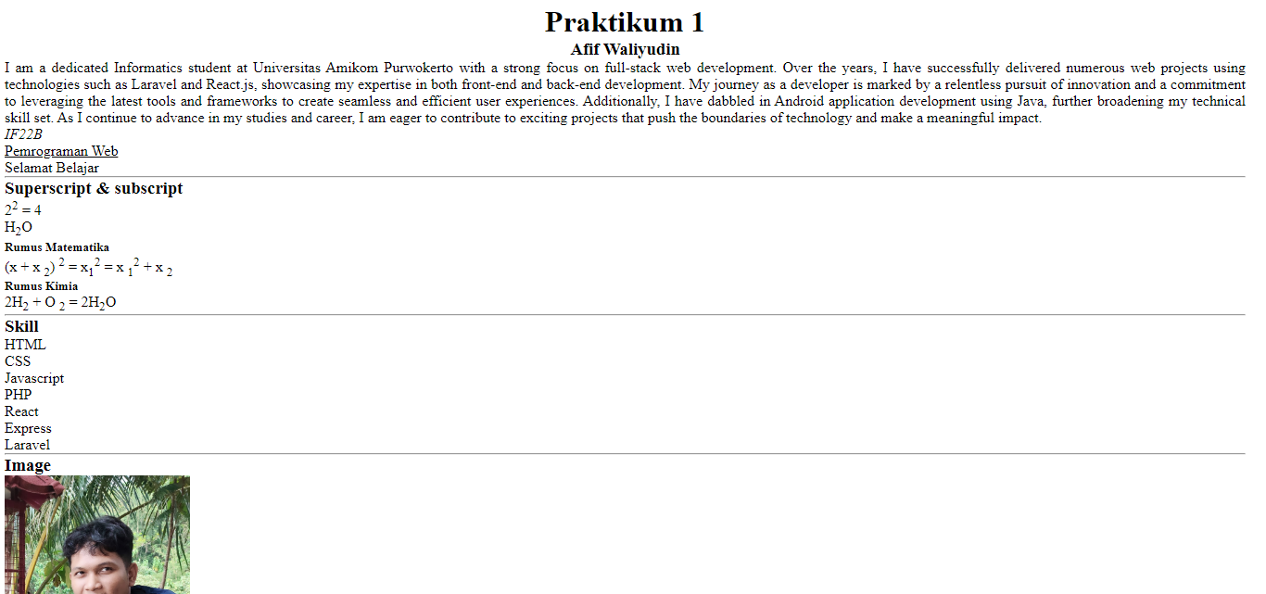

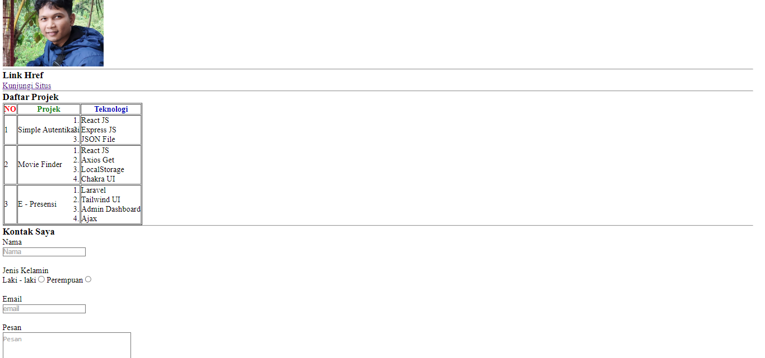

**#2 Latihan**

**Codingan**

<!DOCTYPE html>

<html lang="en">

<head>

    <meta charset="UTF-8">

    <meta name="viewport" content="width=device-width, initial-scale=1.0">

    <title>Ujian HTML</title>

    <link rel="stylesheet" href="https://cdnjs.cloudflare.com/ajax/libs/font-awesome/6.6.0/css/all.min.css" integrity="sha512-Kc323vGBEqzTmouAECnVceyQqyqdsSiqLQISBL29aUW4U/M7pSPA/gEUZQqv1cwx4OnYxTxve5UMg5GT6L4JJg==" crossorigin="anonymous" referrerpolicy="no-referrer" />

</head>

<body>

    <img src="img/IMG20240924100952.jpg" width="150" height="150" alt="Gambar Saya">

    <h1>Afif Waliyudin</h1>

    <p>

        <a target="_blank" href="https://github.com/afifudin24"><i class="fa-brands fa-github"></i> Github</a>

        <a href="https://www.instagram.com/ngidecode/"><i class="fa-brands fa-instagram"></i> Instagram</a>

    </p>

    <h1>Daftar Kendaraan</h1>

    <ol>

        <li><b color="blue"><font color="blue">Kendaraan Darat</font></b></li>

        <ol>

            <li><i>Motor</i> </li>

            <li><i>Mobil</i></li>

            <li><i>Becak</i></li>

        </ol>

        <li><b><font color="blue">Kendaraan Laut</font></b></li>

        <ol>

            <li><i>Kapal</i> </li>

            <li><i>Perahu</i></li>

            <li><i>Kapal Selam</i></li>

        </ol>

        <li><b><font color="blue"> Kendaraan Udara</font></b> </li>

        <ol>

            <li><i>Pesawat</i></li>

            <li><i>Helikopter</i></li>

            <li><i>Jet</i></li>

        </ol>

    </ol>

    <script src="https://cdnjs.cloudflare.com/ajax/libs/font-awesome/6.6.0/js/all.min.js" integrity="sha512-6sSYJqDreZRZGkJ3b+YfdhB3MzmuP9R7X1QZ6g5aIXhRvR1Y/N/P47jmnkENm7YL3oqsmI6AK+V6AD99uWDnIw==" crossorigin="anonymous" referrerpolicy="no-referrer"></script>

</body>

</html>

**Output :**

